**Adamas University**



**School of Engineering and Technology**

**(Department of Electrical Engineering)**

**Mini Project Report**

**On**

**Automatic Room Light Controller Using Arduino And PIR Sensor**

***Submitted By***

**Pratik Das UG/02/BTEE/2018/003**

**Sachin Biswas UG/02/BTEE/2018/004**

**Rakesh Kumar Mishra UG/02/BTEE/2018/007**

**Arunabha Sarkar UG/02/BTEE/2018/011**

**Aditi Biswas UG/02/BTEE/2018/017**

**Abstract**

Automatic Room Light Controller Using Arduino and PIR Sensor can be used to turn ON and OFF the lighting system of home / office routinely by sensing the presence of a human in a predefined aera. Such automatic room light system can be implemented in garages, staircases, bathrooms, lift lobby etc. where we do not need constant light but only when individuals are existing. Also, with the assistance of this system, we can save the energy bill as power will be consumed only when human is present. Proposed method can help us to reduce the consumption of electricity. The main components of this project are Arduino Uno, PIR Sensor and the Relay Module.

**Image Of The Project**

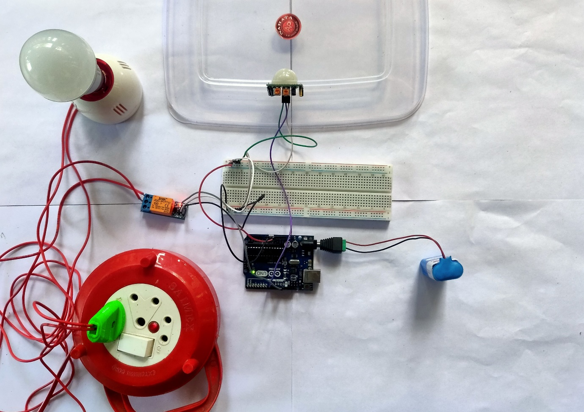

**Fig: Automatic Room Light Controller Using Arduino and PIR Sensor**

**Index**

|  |  |  |
| --- | --- | --- |
| **Sl. No.** | **Content** | **Page No.** |
| 1 | Introduction | 4 |
| 2 | Components Required | 5 |
| 3 | Details Of Main Components | 6 |
| 4 | Software Used | 7 |
| 5 | Circuit Diagram | 8 |
| 6 | Code | 9 |
| 7 | Explanation Of Code | 9 |
| 8 | Working Of The System | 10 |
| 9 | Application | 11 |
| 10 | Future Scop | 11 |
| 11 | Conclusion | 12 |
| 12 | References | 13 |

**Introduction**

Scientific discoveries deliver us luxury and comforts. Technology has become vital and essential part of our lives. Tremendous advancement in technology is succeeded in last few years. Electrical energy has become a crucial part of human life. In recent years the people are looking forward for automation in their day-to-day life and even now people are excited to save energy consumed to reduce the expenditures. People are becoming lazy to switch off the lights while leaving the room, so the large amount of energy is wasted if the light is remained ON in the absence of human being. Generally, in the public and private sector companies, offices, schools and colleges most of the people are not interested to switch OFF the electrical appliance like light, fan etc. while going out of the room.

Using automation in switching the home or office lighting system, the consumption of electricity can be comprehensively reduced, which will in turn save the money of the owner. Now the people are looking forward for automation in their daily life. The people are trying to reduce human efforts.

To overcome this problem, we have developed a device, Automatic Room Light Controller Using Arduino and PIR Sensor, that can be fitted in office or home and can be used to turn ON and OFF the lighting system automatically by detecting the presence of human. There is no need to worry about the electricity bills as the light get OFF when there is no human and hence one need to pay the bills as per use. To detect the presence of human, we are using PIR sensor. Brain of the system is Arduino Uno which will drive the PIR sensor and light. Relay module is used to control the lighting system.

**Components Required**

Required components and their specifications are as follows:

|  |  |  |  |
| --- | --- | --- | --- |
| **Sl. No.** | **Name of component** | **Quantity** | **Specification** |
| 1 | Arduino UNO | 1 | Microcontroller: Microchip ATmega328p, Operating voltage: 5V, Digital I/O pins:14, Analog Input Pins:6 |
| 2 | PIR Sensor (HC-SR501) | 1 | 4.5-20V, <50µA, Sensing range:<120°, within 7m |
| 3 | Single channel Relay Module | 1 | Voltage: 5V, Max. switching voltage:250V AC/30V DC,  Max switching current: 10A |
| 4 | AC LED Bulb | 1 | 9W,220-240V AC, Base Type: B22 |
| 5 | Breadboard | 1 | 400 points |
| 6 | Jumper wire | 8 | Male to Male, Male to Female |
| 7 | Lithium Battery | 1 | 9V DC |
| 8 | Bulb Holder | 1 | Base type: B22 |

**Details Of Main Components**

* **Arduino UNO:**

The Arduino Uno is an open-source microcontroller board based on the Microchip ATmega328P microcontroller and developed by Arduino.cc. The board is equipped with sets of digital and analog input/output (I/O) pins that may be interfaced to various development boards (shields) and other circuits. The board has 14 digital I/0 pins (six capable of PWM output), 6 analog I/0 pins, and is programmable with the Arduino IDE (Integrated Development Environment), via a type B USB cable. It can be powered by the USB cable or by an external 9-volt battery. It also has 16 MHz ceramic resonators, a USB connection jack, an external power supply jack, an ICSP (incircuit serial programmer) header and a reset button. Its operating voltage is 5v, input voltage 7 to 12v (limit up to 20v).

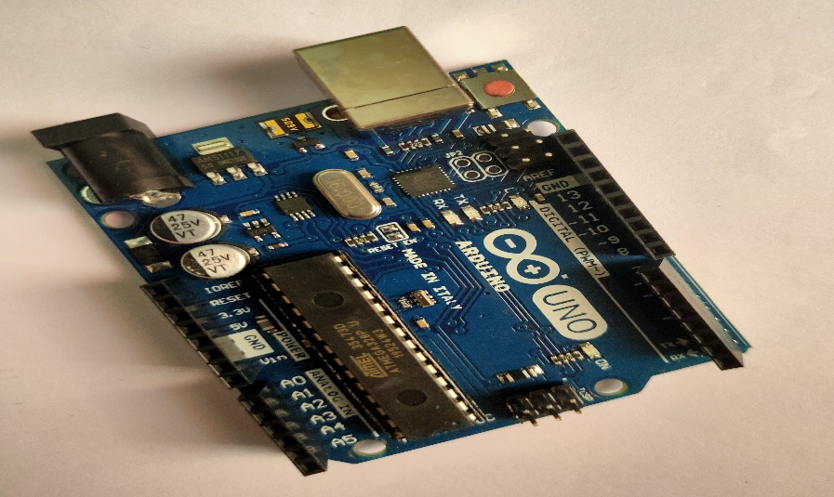

**Fig: Arduino UNO**

* **PIR Sensor:**

A Passive Infrared Sensor (PIR) module is used for motion detection. It consists of pyroelectric sensor that detect motion by measuring the change in the infrared levels emitted by the objects. It requires 10-60 seconds of setting time before starting its operation. It can detect motion up to 6 meters.

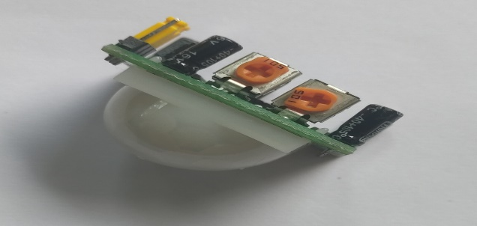

**Fig: PIR Sensor**

* **Relay Module:**

[Relay](https://circuitdigest.com/article/relay-working-types-operation-applications) is an electromagnetic switch, which is controlled by small current, and used to switch ON and OFF relatively much larger current. Means by applying small current we can switch ON the relay which allow much larger current to flow. Relay is the good example of controlling the AC (alternate current) devices, using a much smaller DC current.  Commonly used Relay is **Single Pole Double Throw (SPDT)** Relay, it has five terminals.

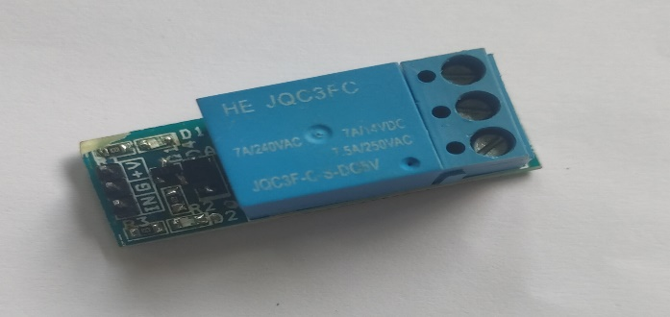

**Fig: Relay Module**

When there is no voltage applied to the coil, COM (common) is connected to NC (normally closed contact). When there is some voltage applied to the coil, the electromagnetic field produced. Which attract the Armature (lever connected to spring), and COM and NO (normally open contact) gets connected, which allow larger current to flow. Relays are available in many ratings, here we used 5V operating voltage relay, which allow 10A-250VAC current to flow.

**Software Used**

Software used to control this system is Arduino IDE (Integrated Development Environment). This software is used to write the program and compile it to the Arduino Uno board. Therefore, Arduino software commands control the Arduino Uno board, sensing device and another circuitry.

**Circuit Diagram**

The following image shows the circuit diagram of the project implemented using Arduino Uno, PIR sensor and a Relay module.

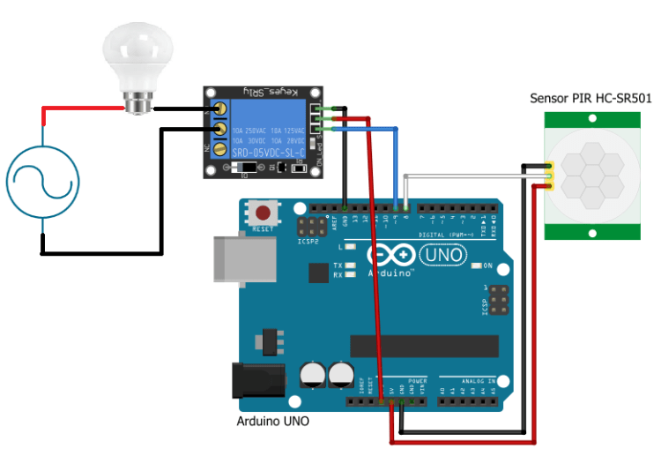

**Code**

int sensor_pin = 8; // Initialized the pin for PIR sensor  
int relay_pin = 9; // Initialized the pin for Relay module

int output = 0; // variable for reading the pin status

void setup() {

Serial.begin(9600);

pinMode(sensor_pin, INPUT); //Declared the PIR sensor pin as Input pin

pinMode(relay_pin, OUTPUT); // Declared the Relay module pin as Output pin

}

void loop(){

output = digitalRead(sensor_pin); // Read the output state of PIR sensor

// If output is High

if( output==1) {

digitalWrite(relay_pin,LOW); // Turn ON the lamp

}

// If output is Low

else {

digitalWrite(relay_pin,HIGH); // Turn OFF the lamp

}

}

**Explanation Of Code**

First of all, we have initialized the pins where we have connected the PIR Sensor and Relay pin. Then we have initialized a variable name “output” which will store the output state of the motion sensor.

In the setup function, we have declared the PIR Sensor pin as input pin because the Arduino will take the PIR sensor’s output and we have declared the Relay pin as output pin because Arduino will give the output to the Relay module to control it.

In the loop function, we have read the output of the PIR Sensor and checked that whether the output is HIGH or LOW. If the output will be HIGH, then the Relay will turn on and the Light will start to glow and if the output will be LOW, then light will get off.

**Working Of The System**

The Automatic Room Lights using Arduino and PIR Sensor is a simple project, where the lights in the room will automatically turn on upon detecting a human motion and stay turned on until the person has left or there is no motion.

Working of this project is very simple and is explained here.

Initially, when there is no human movement, the PIR Sensor doesn’t detect any person and its OUT pin stays LOW. As the person enters the room, the change in infrared radiation in the room is detected by the PIR Sensor.

As a result, the output of the PIR Sensor becomes HIGH. Since the Data OUT of the PIR Sensor is connected to Digital Pin of Arduino, whenever it becomes HIGH, Arduino will activate the relay by making the relay pin LOW (as the Relay module is an active LOW module).

This will turn the light ON. The light stays turned ON as long as there is movement in front of the sensor.

If the person takes a nap or leaves the room, the IR Radiation will become stable (there will be no change) and hence, the Data OUT of the PIR Sensor will become LOW. This in turn will make the Arduino to turn OFF the relay (make the Relay pin HIGH) and the room light will be turned OFF.

**Applications**

Few applications of Automatic Room Light Controller Using Arduino And PIR Sensor are:

* Garage Light
* Staircase Light
* Bathroom Light
* Lift lobby Light

**Future Scope**

In the proposed system decision are taken based on presence of human but here we can also interface LDR (Light Dependent Resistor) along with PIR sensor for better working of the system. This system can also be interfaced with the Bluetooth module so the whole system can be controlled from the mobile by just single click. Applications of this system are:

1. It can be used in college labs, schools, etc.
2. It can also be used in bathrooms, staircases, etc. in the house.

**Conclusion**

From the proposed system, we can conclude that an approach is taken to control the room lights using various devices. As nowadays enormous amount of energy is wasted in daily life. With the help of this system the energy wastage can be preserved and can be contributed to large amount of power saving. This total effective cost of this system is very less.

**References**

* Jaeseok Yun and Sang-Shin Lee, “Human Movement Detection and Identification Using Pyroelectric Infrared Sensors” Sensors 2014
* Subitha M.B “Microcontroller based tracking system for the detection of Human presence in critical Areas” vol.2, Issue 4, IJEDR 2014
* Karthikeyan.R.A, Saran Sriram K, Piyush.D “Automatic Lighting Using Arduino and PIR Sensor”, International Journal of Computer Science Trends and Technology, Volume 6, Sept-Oct 2018.